Synopsis on
“Agri Connect”

For
SPCL Infotech Services Pvt. Ltd

By
Samruddhi Yande

Submitted to
SAVITRIBAI PHULE PUNE UNIVERSITY, PUNE
For the partial fulfillment of the internal credit work of
MASTERS OF COMPUTER APPLICATION SEM – IV

Through


Zeal Education Society’s
Zeal Institute of Business Administration, Computer Application & Research (ZIBACAR)
Sr. No. 39, Narhe, Pune -411041, Phone No.:67206031
(Approved by A.I.C.T.E., New Delhi, Recognized by DTE, Govt. Maharashtra & Affiliated to S.P.P.U. Pune)

2025-2026

Project Synopsis
- Course Name | Masters in Computer Application (IVth Semester)
- Roll No with Div | MC2426128, Div: B
- Student’s Name | Samruddhi Sandip Yande
- Project Title | Agri Connect
- Name of Internal guide | Prof.
- Name of External guide | Prathmesh Ranpise
- Name of Organization | SPCL Infotech Services Pvt.Ltd
- Date of Submission | 30/01/2026
Organization Profile
- Name | SPCL Infotech Services Pvt.Ltd
- Location | Warje, Pune
- About Organization | SPCL Infotech Services Pvt Ltd.is a faithful, honoured and trusted IT organisation enabling services, products and solutions to our clients which are spread over different domains in all over the world.  Use Case for Augmented Reality in design, Implications of Thinking in Blocks Instead of Blobs,  An Extensive Guide to Progressive Web Applications,  Strategies For Headless Projects with Structured,  Content Management Systems.
Project Details
- Abstract | Agriculture is the backbone of the Indian economy, yet a large number of farmers are still unaware of government schemes, their eligibility, actual benefits, and proper procedures to avail them. Even when farmers have partial information, lack of transparency, manual processes, delays, and involvement of intermediaries often result in reduced benefits reaching the farmers. Additionally, farmers face challenges in selling their produce efficiently due to the absence of direct communication with dealers and lack of product tracking mechanisms.  The proposed system, Agri Connect – Farmer–Dealer & Government Scheme Transparency Platform, aims to bridge this gap by providing a single digital platform that offers multilingual access (English, Hindi, and Marathi), transparent scheme information, eligibility checking, real-time scheme status tracking, and direct farmer-to-dealer interaction. The system also enables faster product selling, price negotiation, and product tracking, thereby reducing dependency on middlemen. This platform enhances transparency, reduces corruption, saves time, and empowers farmers with accurate and timely information.
- Existing system | agriwelfare.gov.in
- Proposed system | The proposed system is a web-based, multilingual agricultural support platform designed to improve transparency, efficiency, and communication between farmers, dealers, and government authorities.  Key Features of the Proposed System:  Multilingual Interface: Supports English, Hindi, and Marathi for better accessibility.  Role-Based Modules:  Farmer Module: View schemes, check eligibility, track application status, sell products, and track orders.  Dealer Module: View farmer products, place offers, manage orders, and track deliveries.  Government Module: Manage schemes, monitor applications, approvals, and benefit distribution.  Admin Module: User management, scheme management, complaint handling, and reporting.  Scheme Transparency System: Displays actual scheme benefits, approval stages, and expected amount to be received.  Eligibility Checker: Helps farmers identify schemes applicable to them based on land, crop, and location.  Farmer–Dealer Direct Deal: Enables faster selling and fair pricing without intermediaries.  Product Tracking System: Tracks product status from farmer to dealer.  Complaint & Feedback System: Allows farmers to report issues related to schemes or payments.  The proposed system overcomes the limitations of existing systems by ensuring transparency, speed, accountability, and ease of use, thereby creating a trustworthy digital ecosystem for farmers.
- Scope of the System | The scope of the project defines the boundaries and functionalities covered by the proposed system.  - To provide centralized information about government agricultural schemes in a simple and understandable format.  - To support multilingual access (English, Hindi, Marathi) for better reach among farmers.  - To enable role-based access for Farmers, Dealers, Government Authorities, and Admin.  - To allow farmers to check eligibility, benefits, and real-time status of applied schemes.  - To provide a direct farmer-to-dealer communication platform for faster and profitable product selling.  - To support product tracking from farmer to dealer to ensure transparency.  - To reduce dependency on manual processes and intermediaries.  The system is scalable and can be extended to include more schemes, regions, and analytics in the future.
- Objectives of System | The main objectives of the proposed system are as follows:  - To spread awareness about government agricultural schemes among farmers.  - To ensure transparency in scheme benefits, amounts, and approval processes.  - To reduce corruption and unauthorized deductions in scheme disbursement.  - To provide a fast and user-friendly digital platform for farmers.  - To enable direct interaction between farmers and dealers without middlemen.  - To reduce the time required for selling agricultural products.  - To provide real-time tracking of schemes and product delivery.  - To empower farmers with accurate information and decision-making ability.  - To make the system easy to use, visually simple, and accessible even for less tech-savvy users.
- Environment
- Operating system | Windows 10
- Front End | HTML, CSS, React, JavaScript
- Back End | Java
7. Internship Offer/Appointment Letter | 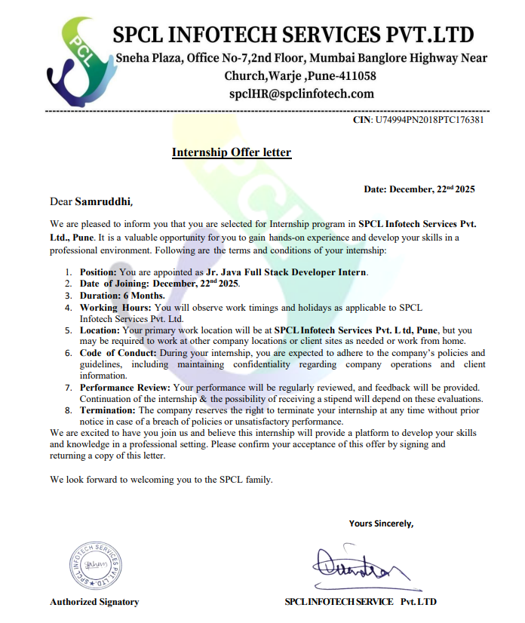
8. Any other (please specify)

Date:

Student Sign External Guide Sign Internal Guide Sign Project coordinator Sign
SPECIFICATIONS FOR PROJECT SYNOPSIS

- The synopsis shall be computer typed (Font -Times New Roman, Size-12 point, heading 14 point, Line spacing-1.5) and printed on A4 size paper.
- Paragraph must be justified.
- The Synopsis shall be typed on both the sides of and Insert page numbers.
- Margins must be:
Left 1.5 inches Right 1 inches
Top 1 inches Bottom 1 inches
- Wherever required use a numbered list, emphasis on abbreviations, long forms, keywords using some type of formatting.
- Project synopsis submission as per schedule.
Note: Remove this print at the time of printing & submission

